**Nomz, Inc – Pre Campaign Report**

### Client Profile: Nomz is a New York City based startup providing convenient, traditional, and healthy frozen soup for busy Asian American individuals. The company was launched in August 2015. Nomz currently has two full-time employees (the co-founders) and multiple part-time employees. Currently, Nomz only offers two products, Chinese Chicken Shiitake Mushroom Soup, and Vietnamese Pho Soup. Both products are priced on a premium starting at $8. Nomz only sells its products online at [www.eatnomz.com](http://www.eatnomz.com) and delivers the soup to customers in downtown Manhattan through bike couriers. The company sells on average 15-20 soups a week and has generated estimated revenue of $9,825 since its launch.

### Eatnomz.com is hosted by Shopify and currently managed by Tony Wu, one of the founders. Along with the website, Tony also manages the social media presence of the company through Facebook, Instagram and Twitter, and a company blog.

### Market Analysis: Nomz is primarily targeting Asian Americans located in New York, NY between the ages of 20 and 34 years old. Currently, there are 4.7 million young Asian Americans living in the United States with 441,000 of then living in the greater New York Area. Asian American is not only the fastest growing racial population within the United States, it is also the wealthiest in terms of median personal income. Because both founders are Asian and well-connected to the young Asian American community, they pose distinctive competitive advantages relative to their competitors within this demographic.

### Nomz currently has two major groups of competitors: frozen Asian food providers such as Wei Chuan, and food delivery services such as Orderup. Frozen Asian food providers are well-established in the Asian American community, but price their products at discount and do not tailor their products to the needs of young Asian Americans. Food delivery services are popular among the 20-34 yrs old age group, but do not target specifically Asian Americans. Whereas Traditional frozen food companies spend very little on Google Adwords, food delivery services spend millions of dollars every year on Google Adwords, covering virtually all keywords related to food delivery.

### Nomz occupies a distinct niche between the frozen food and food delivery industry. Compare with frozen Asian food providers, Nomz provide young Asian Americans a healthier, more accessible, and more convenient product priced at premium. Compare with food delivery companies, Nomz tailor specifically to the soup need of young Asian Americans - a category that is currently unexploited by food delivery companies.

### Current Marketing: Most of Nomz’s marketing efforts are done through word of mouth, both in person and through the social media. In person, the founders have leveraged their personal connections in New York to obtain initial adopters. In fact, over 20% of the customers were the founders’ personal friends. The founders also gave talks at multiple universities in New York and participated in many local food shows to further publicize the products. Online, Nomz utilizes social media to engage its core customer group and collect positive word of mouth. Since its launch, it has gathered over 35 reviews on Facebook and collected five star ratings in all posted reviews. The company has not spent any money on online or offline advertising to date.

Eatnomz.com - the company’s website and sole point of sales, current receives on average 1000 views per month with bounce rate of 40.55%. Most of the site visitors came through direct link (46.67%), followed by organic search (24.26%) and site referrals (15.15%). Major portion (46%) of cite referrals come from the client’s Facebook page. Low search traffic is an illustration of the client’s lack of online marketing efforts.

### Conclusion: The major factor that attracted our team to Nomz is its potential. The company has already gained much traction in the New York Asian American Community and received rave reviews without any expenses spent on marketing. We believe the Google Online Marketing Challenge poses a great opportunity for Nomz to improve its online presence and further engage its target customers in the New York City area.

**Proposed AdWords Strategy:** The primary objectives of our online marketing campaign is to raise awareness on Nomz’s brand, and the difference between Nomz’s products and other frozen Asian food products or Asian food delivery cuisines. The secondary is to boost the company’s sales. We aim to achieve accomplish these objectives with 5 campaigns and 14 ad groups. Broad match, Broad match modifier, phrase match, exact match and negative keywords will be used for each campaign. Examples of negative keywords will be [-takeout] and [-restaurant], as the Nomz business does not follow a takeout model nor does it have a physical restaurant. All campaigns will be geo-targeting New York, New York, the only area that the company currently serves.

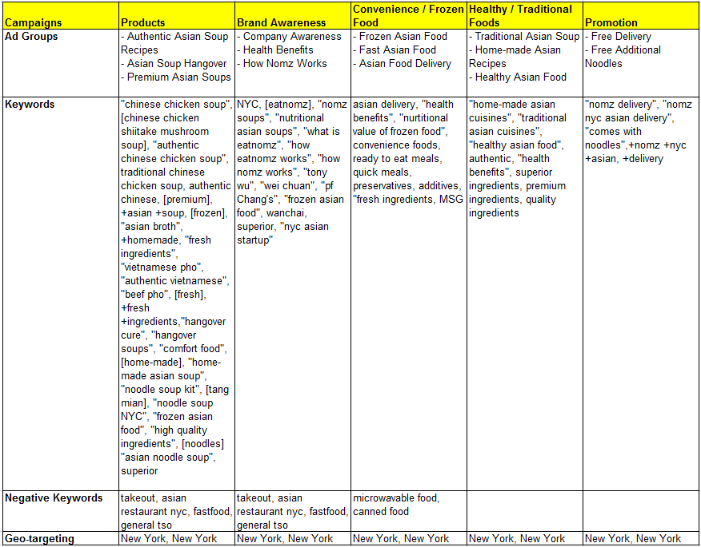

The **Products** campaign aims to drive sales of all products and determine which products are the most attractive to customers. The ad groups are targeted at customers who are looking for authentic or premium Asian soup cuisines or Asian soup cuisines as hangover cures. The **Brand Awareness** campaign will be segmented into three main groups to spread awareness about the Nomz brand, how the service works, and differentiate itself from its competitors by highlighting the health benefits of its products. The **Convenience / Frozen Food** campaign will be used to combat common ideas or misunderstandings about frozen food products while highlighting the absence of preservatives or additives in Nomz’s products. It also aims to promote Nomz to consumers who are looking for food that can be delivered to them and / or frozen and eaten several days later, when it is convenient for them. The **Healthy / Traditional Foods** campaign targets consumers who are looking for healthy and traditional Asian cuisines. The **Promotion** campaign aims to drive and create demand for the Nomz brand. This campaign is especially important since Nomz is its infancy stages. This campaign will also be used strategically for our geo-targeting efforts and provide free delivery or free additional noodles to users who can only participate in it.

For our ad copies, we will look to match the headline with the search query with the unique value proposition on the following lines. Each ad group will have 2-3 ads and we will look to rotate these ads during the first week, and we will use metrics such as CPC and CTR to decide which ad copies to use. We will then remove the poor performing keywords based on the CTR and CPC and optimal keywords suggested by Google under the opportunities tab and Google Bid Simulator tool will be used for further optimizations.

**Sample Ad Copies:**

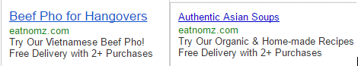

**Budget:**

|  |  |  |  |  |  |
| --- | --- | --- | --- | --- | --- |
| **PPC Budget** | **Campaign Budget** | | **Week 1** | **Week 2** | **Week 3** |
| **Campaign** | **Percent** | **$ Budget** | 20% | 40% | 40% |
| **Products** | 30% | $75.00 | **$15.00**, *$2.14/day* | **$30.00**, *$4.29/day* | **$30.00**, *$4.29/day* |
| **Brand Awareness** | 30% | $75.00 | **$15.00**, *$2.14/day* | **$30.00**, *$4.29/day* | **$30.00**, *$4.29/day* |
| **Frozen / Convenient Foods** | 15% | $37.50 | **$7.50**, *$1.07/day* | **$15.00**, *$2.14/day* | **$15.00**, *$2.14/day* |
| **Healthy / Traditional Asian Foods** | 10% | $25.00 | **$5.00**, *$0.71/day* | **$10.00**, *$1.43/day* | **$10.00**, *$1.43/day* |
| **Promotions** | 15% | $37.50 | **$7.50**, *$1.07/day* | **$15.00**, *$2.14/day* | **$15.00**, *$2.14/day* |
| **Total** | 100% | $250.00 | $50.00 | $100.00 | $100.00 |

We are strategically allocating 70% of the budget to raising brand awareness and recognition efforts since the company is in its infancy, 30% will be allocated to products, which aims to drive sales.

**Objectives and KPIs:** We expect to generate $300 worth of additional sales through the GOMC campaign, with an ad spend of $250, thus an ROI of 20%. Since the campaign will run in Manhattan city which has many Asian food delivery options, we expect total impressions to be 15,000 with a CTR of 2%, thus generating 300 clicks, resulting in an average CPC across all keywords to be $0.83.